Paul Baxter

Jareth_2005@yahoo.com

Abstract

User manual for installing and using the Pasm Assembler

Pasm

User Manul

Table of Contents

Instalation 2

Downloading 2

Building/Install 3

Windows 3

Linux 6

# Instalation

## Downloading

First you should make sure CMake is installed. CMake can be download from <https://cmake.org/download/>

You should also have a C++ compiler for whatever platform you are on. If you have Visual Studio installed, that will work.

If you are using Windows, you can download WinFlexBison from

<https://github.com/lexxmark/winflexbison>

Be sure to add the path to the %PATH% environment variable so cmake can find it.

If you are using Linux:

sudo apt-get update

sudo apt-get install flex

sudo apt-get install bison

which flex /*Sanity check to make sure flex is installed*/

which bison /*Sanity check to make sure bison is installed*/

PASM is open source and is available on GitHub at

<https://github.com/pebmeister/Pasm>

## Building/Install

### Windows

For Windows open a PowerShell in the same level as CMakePasm

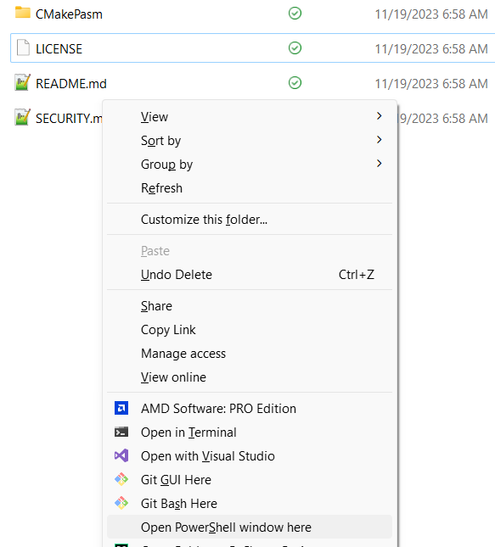

Once the PowerShell Window is open type cmake -S .\CMakePasm\ -B .\WinPasm\

This will put your build directory in WinPasm. You can use whatever directory name you want.

Next type cmake --build .\WinPasm\ --config Release  **NOTE:** there are 2 dashes for –build and --config

This will build pasm.exe in WinPasm\bin\Release folder.

This will also put the samples in the current user Documents/pasm/samples folder.

To Install you will need an Administrator PowerShell

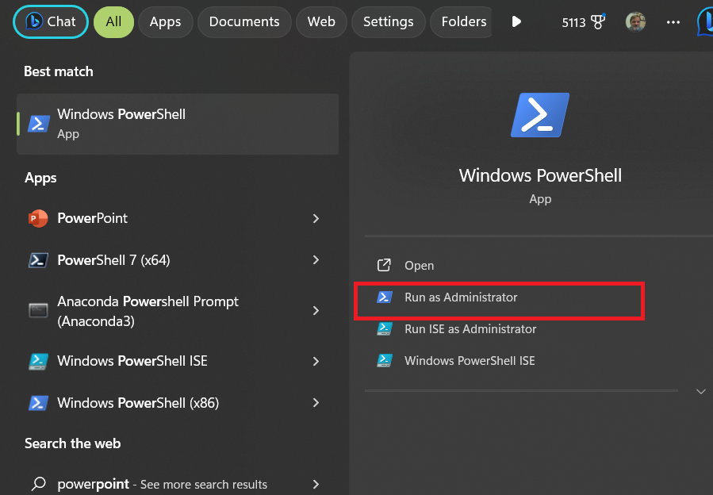

Set the directory to same level as CMakePasm.

Type cmake –install .\WinPasm\ --config Release

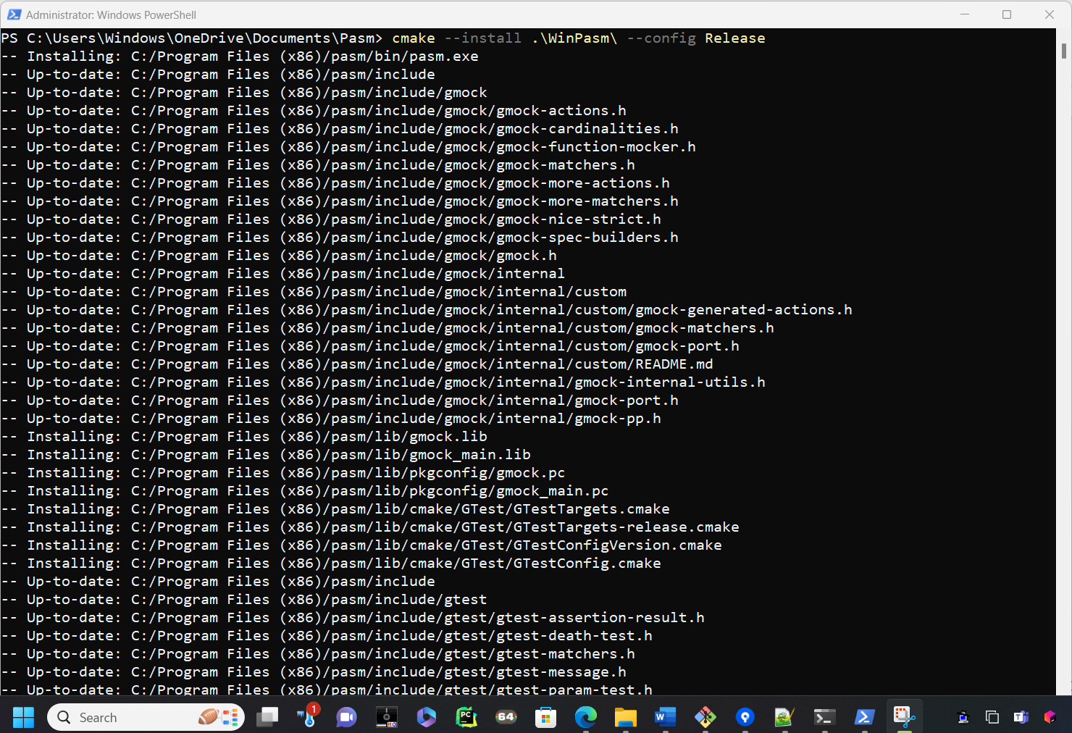

This will install Pasm in Program Files (x86). Pasm will also be in the Windows %PATH% and be able run in any PowerShell or Windows Console!

### Linux

Make sure you are in same level as the CMake directory.

Type cmake -S CMakePasm/ -B LinPasm/

This will put your build directory in LinPasm. You can use whatever directory name you want.

Next Type cmake –build LinPasm/ **NOTE:** there are 2 dashes for –build

PASM is now built in LinPasm/bin/pasm

Type LinPasm/bin/pasm

